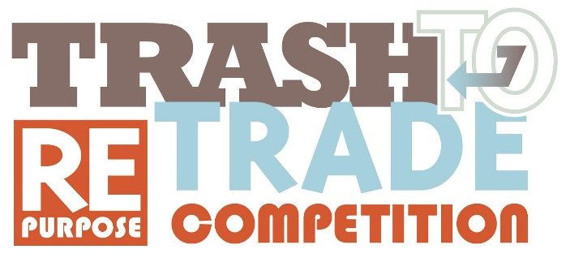

Trash to Trade Competition Entry Form
- Please fill out the form below and send through to infogreylynn2030@gmail.com
- Please also attach photos of before and after of your product and a photo of you/your group
- Please also attach a business plan for your product (if you have one)

Full Name

Age

E-mail

Phone number

Address

Name of organisation, e.g. school, business name, website, etc. Leave blank if not applicable

Which category are you entering?
- Young Makers
- Businesses
- New Designers

Please provide a written summary (350 words maximum) below about how you came to use the raw material, where it comes from (which business stream), why re-purpose, environmental considerations, description of the product, pricing and how you see it being used.

Please provide a brief bio of you/your group

Have you attached a ‘before’ photo of your product?
- Yes
- No

Have you attached an ‘after’ photo of your product?
- Yes
- No
Have you attached a photo of you /your partnership/ your group?
- Yes
- No
Have you attached a business plan?
- Yes
- No

Please submit this form to infogreylynn2030@gmail.com
Regards,
GL2030 Coordinator
E: infogreylynn2030@gmail.com


